**Program Four Part One**

//summary: This program takes in a social security number and makes sure that it is a proper one

//name: Jenna Wolf

//class: Fundamentals of Programming, CS155 - 01

//instructor: Dr. Art Kazmierczak

//date: 9/11/2023

import java.util.Scanner; //allows inputs to be made

public class Main

{

public static void main(String[] args)

{

Scanner input = new Scanner(System.in); //labels input as input

String ss; //holds the ss data

boolean truess = false; //holds the truess data and sets it to false

//asks for and takes in the social security number

System.out.println("Please enter your social security number and we will check if it is correct: ");

System.out.println("make sure to include dashes!");

ss = input.next();

//checks to make sure the length is 11

if(ss.length() == 11)

{

//checks to make sure a proper social security number was entered

if(Character.isDigit(ss.charAt(0)) && Character.isDigit(ss.charAt(1)) && Character.isDigit(ss.charAt(2))

&& ss.charAt(3) == '-' && Character.isDigit(ss.charAt(4)) && Character.isDigit(ss.charAt(5))

&& ss.charAt(6) == '-' && Character.isDigit(ss.charAt(7)) && Character.isDigit(ss.charAt(8))

&& Character.isDigit(ss.charAt(9)) && Character.isDigit(ss.charAt(10)))

truess = true; //sets truess to true

}

//outputs different text depending on the value of truess

if(truess)

System.out.println(ss + " is proper social security number!");

else

System.out.println(ss + "is not a proper social security number!");

}

}

Output:

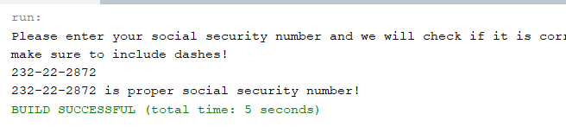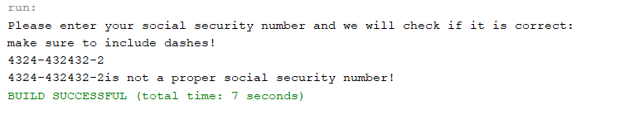

**Program FourPart Two**

//summary: This program takes in employee information and finds the net pay along with other variables

//name: Jenna Wolf

//class: Fundamentals of Programming, CS155 - 01

//instructor: Dr. Art Kazmierczak

//date: 9/11/2023

import java.util.Scanner; //allows inputs to be made

public class Main

{

public static void main(String[] args)

{

Scanner input = new Scanner(System.in); //labels input as input

String name; //holds the name data

double hours, payRate, fedTax, stateTax, grossPay, fedWith, stateWith, netPay; //holds the data for all these variables

//asks for and takes in the name

System.out.println("What is the employee's name?");

name = input.next();

//asks for and takes in the hours

System.out.println("How many hours did the employee work this week?");

hours = input.nextDouble();

//asks for and takes in the pay rate

System.out.println("What is the employee's pay rate?");

payRate = input.nextDouble();

//asks for and takes in the federal tax

System.out.println("What is the federal tax witholding rate? (type in percentage, not decimal)");

fedTax = input.nextDouble();

//asks for and takes in the state tax

System.out.println("What is the state tax witholding rate? (type in percentage, not decimal)");

stateTax = input.nextDouble();

grossPay = hours * payRate; //caculates the gross pay

fedWith = (fedTax / 100) * grossPay; //caculates the federal withdraw

stateWith = (stateTax / 100) * grossPay; //caculates the state withdraw

netPay = grossPay - (fedWith + stateWith); //caculates the net pay

//outputs all information

System.out.println("Employee name: " + name);

System.out.println("Employee pay rate: $" + payRate);

System.out.println("Gross pay: $" + grossPay);

System.out.println("Deductions:");

System.out.println(" Federal Witholding (" + fedTax + "%): $" + fedWith);

System.out.println(" Federal Witholding (" + stateTax + "%): $" + stateWith);

System.out.println(" Total Deductions: $" + (fedWith + stateWith));

System.out.println("Net pay: $" + netPay);

}

}

Output:

